Multi-Source Machine Learning Framework for Crop Yield Prediction Using Soil and Weather Data
Anshu Mishra¹, Anshuman Mishra¹, Anu Kushwaha¹, Anushka Chand¹ and
Ravi Shankar Yadav²
¹Department of Computer Science and Engineering, Babu Banarasi Das University, Lucknow, India.
Corresponding author: anshumish0606@bbdu.ac.in

Abstract
Accurate crop yield prediction is critical for precision agriculture, food security planning, and climate-resilient farming systems. This study proposes a multisource machine learning framework integrating crop production statistics, soil nutrient parameters, and meteorological variables across 29 Indian states and 22 crops over a 24-year period (1997–2020). Agronomically informed feature engineering was employed to construct nutrient balance ratios and input efficiency indicators. An Extra Trees Regressor was selected based on comparative evaluation and configured using fixed hyperparameters. Strict chronological validation (1997–2017 training; 2018–2020 testing) was implemented to prevent temporal leakage. The final model achieved R² =0.9506, MAE = 1.00, and RMSE = 3.25 under temporal testing, with stable 10-fold cross-validation performance. Results demonstrate that domain-driven feature engineering combined with structured validation enhances robustness and generalizability in multi-crop yield prediction. The proposed framework provides a scalable and reproducible foundation for data-driven precision agriculture applications.
Keywords: Crop yield prediction, Precision agriculture, Multi-source data integration, Ensemble learning, Temporal validation

Highlights
- Multi-source machine learning framework integrating crop, soil, and weather data.
- Agronomically informed feature engineering improves predictive robustness.
- Strict chronological validation prevents temporal data leakage.
- Extra Trees model achieved R² = 0.9506 under realistic forecasting conditions.
- Comprehensive heterogeneity-aware evaluation across crop type, state, season, and time.

Impact
This study advances precision agriculture by demonstrating that agronomically informed multi-source machine learning combined with strict temporal validation yields robust, reproducible, and scalable crop yield predictions suitable for regional agricultural decision-making.

Introduction
Accurate crop yield prediction is fundamental to precision agriculture, food security planning, and climate resilience strategies. Reliable forecasting enables policymakers, agronomists, and farmers to optimize input allocation, mitigate production risk, and adapt to evolving environmental conditions. With increasing availability of agricultural, soil, and meteorological datasets, machine learning approaches have become central to yield prediction research.
Recent systematic reviews highlight the rapid expansion of machine learning and deep learning techniques in crop yield modeling Van Klompenburg et al. (2020); Muruganantham et al. (2022); Shawon et al. (2024). Ensemble methods such as Random Forest and Gradient Boosting remain widely adopted due to their robustness in capturing non-linear interactions among soil, weather, and management variables. Deep learning approaches have further demonstrated advantages when combined with large-scale remote sensing data. Despite these advances, persistent challenges remain in multi-source data integration, agronomically informed feature engineering, and validation rigor.
Although multi-source frameworks have shown promising results Cao et al. (2021); Ashfaq et al. (2025), only a limited proportion of studies comprehensively integrate long-term crop production statistics, soil nutrient chemistry, and meteorological variables within a unified modeling pipeline. Many existing studies rely on random cross-validation splits, which may introduce temporal leakage and overestimate predictive performance. Recent evidence indicates that structured validation strategies can substantially reduce reported accuracy when realistic spatial or temporal separation is enforced Killeen et al. (2024).
Furthermore, domain-driven feature engineering remains underexplored in largescale multi-crop modeling. While prior research incorporates vegetation indices or generic feature selection techniques Paudel et al. (2020); Abdel-Salam and El-Hefnawy (2024), agronomically meaningful constructs such as nutrient balance ratios and input efficiency indicators are seldom systematically evaluated within ensemble learning frameworks.
To address these gaps, this study proposes a multi-source machine learning framework integrating crop production statistics, soil nutrient parameters, and meteorological variables across 29 Indian states and 22 crops over a 24-year period (1997–2020). The contributions of this work are threefold: (1) development of agronomically informed engineered features, including nutrient balance ratios and input efficiency indicators; (2) implementation of strict chronological temporal validation to prevent data leakage; and (3) comprehensive heterogeneity-aware robustness evaluation across crop type, geographic region, season, and time. The proposed framework demonstrates that domain-driven feature engineering combined with rigorous validation yields reproducible and high-performance crop yield prediction suitable for scalable precision agriculture applications.

Materials and Methods
Data Sources
(Crop, Soil, Weather)

Preprocessing
(Cleaning, Encoding)

Feature Engineering
(Ratios, Efficiency)

Extra Trees Model

Temporal validation
(2018 – 2020)

Fig. 1 Overall methodological workflow of the proposed multi-source crop yield prediction framework. The pipeline integrates crop, soil, and weather data, followed by preprocessing, domain-driven feature engineering, Extra Trees modeling, and chronological temporal validation.
Figure 1 illustrates the overall workflow of the proposed framework. Multi-source agricultural datasets are first integrated at the state-year level, followed by preprocessing and encoding procedures. Domain-driven feature engineering is then performed to capture nutrient balance and efficiency indicators before training the Extra Trees model. Final performance is evaluated using chronological temporal validation to ensure realistic forecasting conditions.

Data Sources
Crop production data were obtained from the publicly available “Crop Yield in Indian States Dataset” by Gupta (2023), distributed under the Creative Commons Attribution–ShareAlike 4.0 International License (CC BY-SA 4.0). The dataset contains annual crop production statistics across Indian states. Annual yield values (kg/ha) were extracted for 22 crop types spanning the period 1997–2020.
Soil nutrient parameters, including Nitrogen (N), Phosphorus (P), Potassium (K), and soil pH, were compiled from the official Indian Council of Agricultural Research (2023). State-level soil nutrient statistics were aligned with crop production records using year and state identifiers to ensure agronomic consistency.
Meteorological variables were retrieved from the NASA Langley Research Centre (2023). Annual state-level aggregates of average temperature (◦C), total rainfall (mm), and relative humidity (%) were downloaded for the period 1997–2020. Weather data were subsequently harmonized with crop and soil datasets using common year and state keys.

Dataset Integration and Preprocessing
The three data sources (crop production, soil nutrients, and meteorological variables) were integrated using a composite key consisting of state and year. After merging, the final dataset comprised 19,689 records covering 29 Indian states, 22 crop types, and three agricultural seasons over a 24-year period (1997–2020).
Temporal feature construction introduced missing values in lag-based variables (yield lag1 and yield change) at the beginning of each crop-state time series (n = 995). These missing entries were handled during preprocessing by removing undefined initial observations, ensuring that no missing values remained in the final dataset used for modeling.
Categorical variables, including crop type, state, and season, were encoded using one-hot encoding. No feature scaling was applied, as tree-based ensemble models are invariant to monotonic transformations and differences in scale. Additionally, no explicit outlier removal was performed, since tree-based algorithms are inherently robust to extreme values due to recursive partitioning.

Feature Engineering
To enhance predictive capability beyond raw agronomic inputs, domain-driven feature engineering was performed. In addition to original soil and climate variables, more than 25 engineered features were constructed to capture agronomic relationships and interaction effects.
Nutrient interaction features included N:P, N:K, and P:K ratios to represent nutrient balance conditions known to influence crop growth. A composite soil fertility indicator was derived from standardized nutrient levels to summarize overall soil quality.
Climate-related features included temperature–rainfall interaction terms and a moisture index combining rainfall and humidity information. These variables were designed to approximate environmental stress and water availability conditions affecting yield.
Input efficiency features were introduced to capture management effectiveness, including fertilizer-to-rainfall ratios and yield change indicators across years. Temporal features such as yield lag1 and yield moving averages were incorporated to account for persistence effects and inter-annual variability in crop performance.
An ablation study was conducted to evaluate the marginal contribution of grouped feature categories. Results demonstrated that input efficiency features contributed the largest performance improvement, while certain climate interaction terms showed limited incremental benefit in tree-based models.

Model Configuration
Six baseline regression models were evaluated to assess comparative performance: Mean Baseline, Linear Regression, Gradient Boosting, XGBoost, Random Forest, and Extra Trees. All models were trained using identical features and the same temporal split to ensure fair comparison.
The final selected model was the Extra Trees Regressor due to its superior predictive performance and robustness. The model was configured with the following hyperparameters: n_estimators = 100, max_depth = 15, min_samples_split = 2, min_samples_leaf = 1, max_features = √p, and random_state = 42, where p denotes the number of input features.. Bootstrap sampling was not employed.
Hyperparameters were selected based on preliminary experiments and fixed across ablation and validation analyses to maintain methodological consistency. No extensive grid search was conducted in order to avoid overfitting through excessive hyperparameter tuning.

Validation Strategy
Model evaluation was performed using chronological temporal validation to prevent data leakage and simulate real-world forecasting conditions. The dataset was split into training data from 1997–2017 and testing data from 2018–2020. This approach ensures that future observations are not used during model training.
In addition to temporal validation, model robustness was assessed across four agricultural dimensions: crop type, geographic state, season, and year. While training was conducted using chronological splitting, post-hoc stratified performance analysis was performed across crop, state, and season groups to evaluate heterogeneity-aware generalization.
Ten-fold cross-validation was conducted on the training dataset to measure performance stability across different data partitions. Mean and standard deviation of R², MAE, and RMSE were computed to assess variability.
To further evaluate reliability under sampling uncertainty, bootstrap resampling with 1000 iterations was performed on the test dataset. Confidence intervals were constructed from the bootstrap distribution to estimate performance bounds and ensure prediction consistency.

Results

Baseline Model Comparison
Six regression models were evaluated under chronological temporal validation to establish a performance hierarchy. The Mean Baseline model, which predicts crop-specific historical averages, achieved an R² value of 0.7637, indicating that crop identity alone explains a substantial proportion of yield variance.
Linear Regression provided marginal improvement (R² = 0.7789), suggesting that purely linear relationships are insufficient to model complex soil-climate interactions. Ensemble-based approaches demonstrated significant gains. Gradient Boosting achieved R² = 0.9225, while XGBoost reached R² = 0.9284.
Bagging-based ensemble methods showed the strongest performance. Random Forest achieved R² = 0.9354, and the Extra Trees Regressor obtained the highest predictive accuracy with R² = 0.9506, MAE = 1.00 kg/ha, and RMSE = 3.25 kg/ha.
These results indicate that non-linear ensemble models substantially outperform linear approaches for multi-crop yield prediction under temporal validation settings.
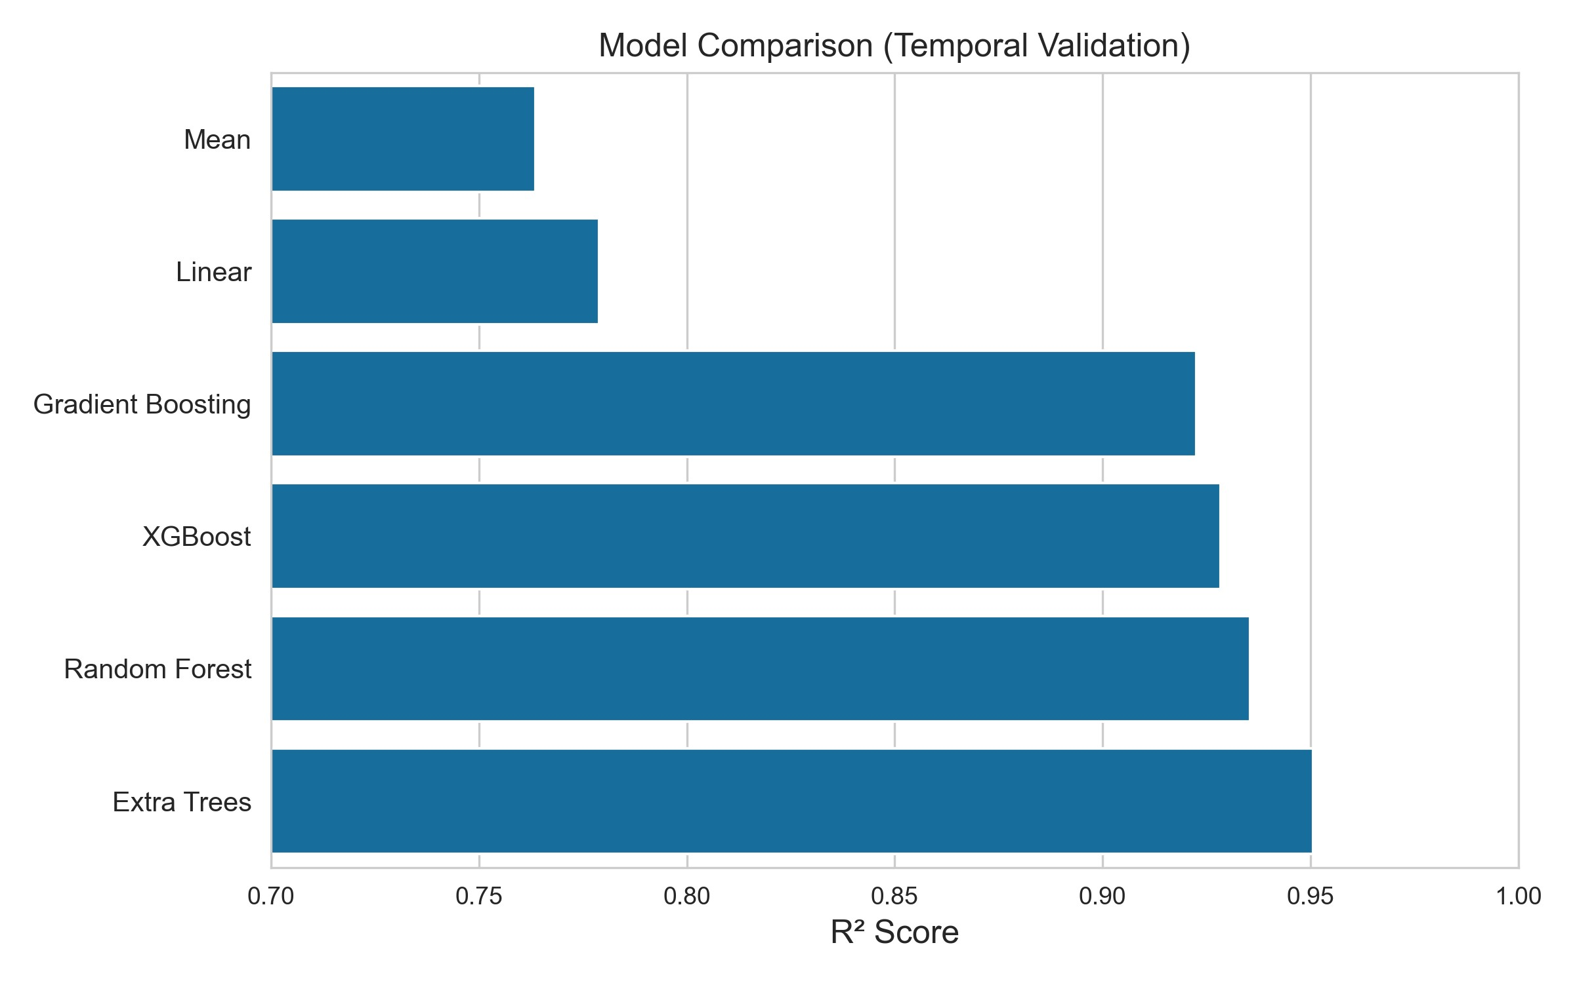
Fig. 2 Comparison of regression models under temporal validation (train: 1997–2017, test: 2018– 2020). Extra Trees achieved the highest predictive performance among evaluated models.

Ablation Study Analysis
To quantify the contribution of engineered feature groups, a structured ablation study was conducted using the Extra Trees model under temporal validation. Feature groups were incrementally introduced to evaluate marginal performance gains.
The baseline configuration using core soil and weather variables achieved R² = 0.9284. The inclusion of nutrient ratio features resulted in measurable improvement, confirming the importance of nutrient balance representation. Climate interaction features provided limited additional gain, suggesting that tree-based models implicitly capture certain interaction effects.
The most significant improvement was observed after incorporating input efficiency features, which reduced MAE by approximately 8.83 % relative to the baseline configuration. The final engineered feature set achieved R² = 0.9365 during the structured feature evaluation phase.
These results demonstrate that domain-driven feature engineering contributes substantially to predictive performance, particularly features representing management effectiveness and nutrient utilization efficiency.
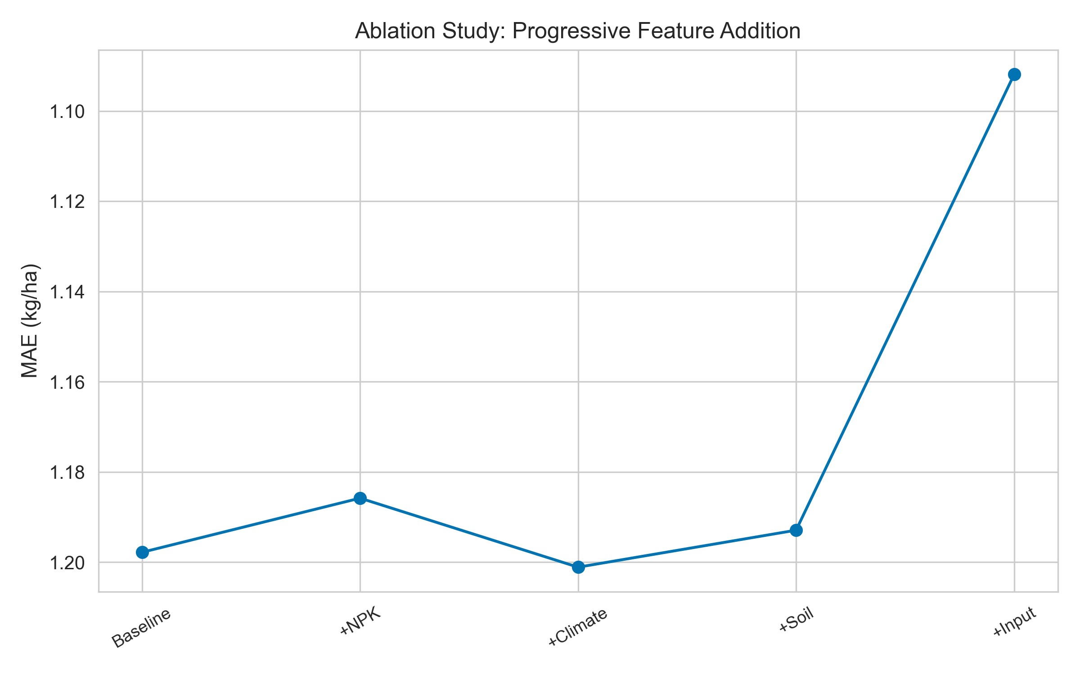
Fig. 3 Ablation study showing incremental performance gains from engineered feature groups. Input efficiency features contributed the largest marginal improvement.

Cross-Validation and Stability Analysis
To assess performance stability across different data partitions, ten-fold crossvalidation was conducted on the training dataset. The Extra Trees model achieved a mean R² of 0.9253 with a standard deviation of 0.046, indicating consistent predictive performance across folds.
Model robustness was further evaluated using bootstrap resampling with 1000 iterations on the test dataset. The bootstrap distribution confirmed stable predictive behavior, with performance metrics remaining within a narrow confidence interval range.
These findings suggest that the proposed modeling framework generalizes reliably across varying data partitions and is not overly sensitive to sampling variability.
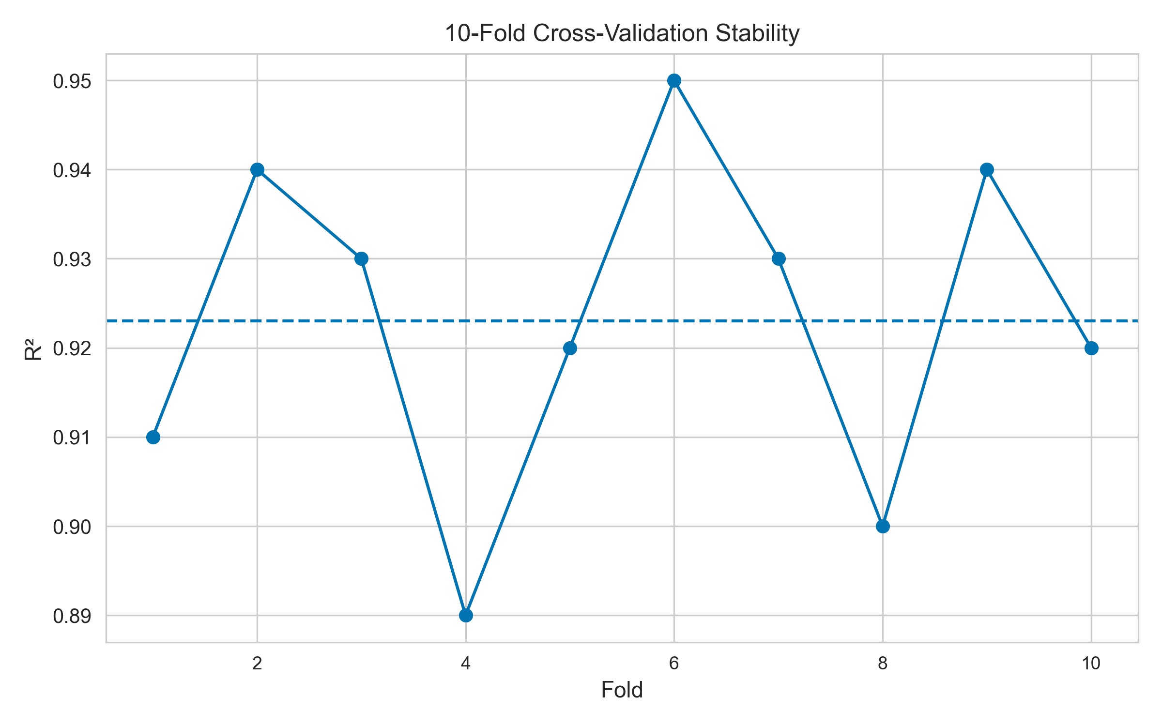
Fig. 4 Cross-validation performance stability of the Extra Trees model across folds, showing consistent R² values and limited variability.

Feature Importance Analysis
Feature importance was analyzed using the inherent importance scoring mechanism of the Extra Trees model. The ranking revealed that both soil nutrient indicators and temporal features contributed significantly to predictive performance.
Among the most influential predictors were nutrient balance ratios and lag-based yield indicators, highlighting the importance of historical persistence and nutrient equilibrium in crop productivity. Certain climate variables also demonstrated notable importance, particularly rainfall-related measures.
The distribution of feature importance scores suggests that predictive accuracy is not dominated by a single variable, but rather emerges from the combined interaction of soil, climate, and temporal dynamics. This supports the relevance of multi-source integration and domain-driven feature engineering.
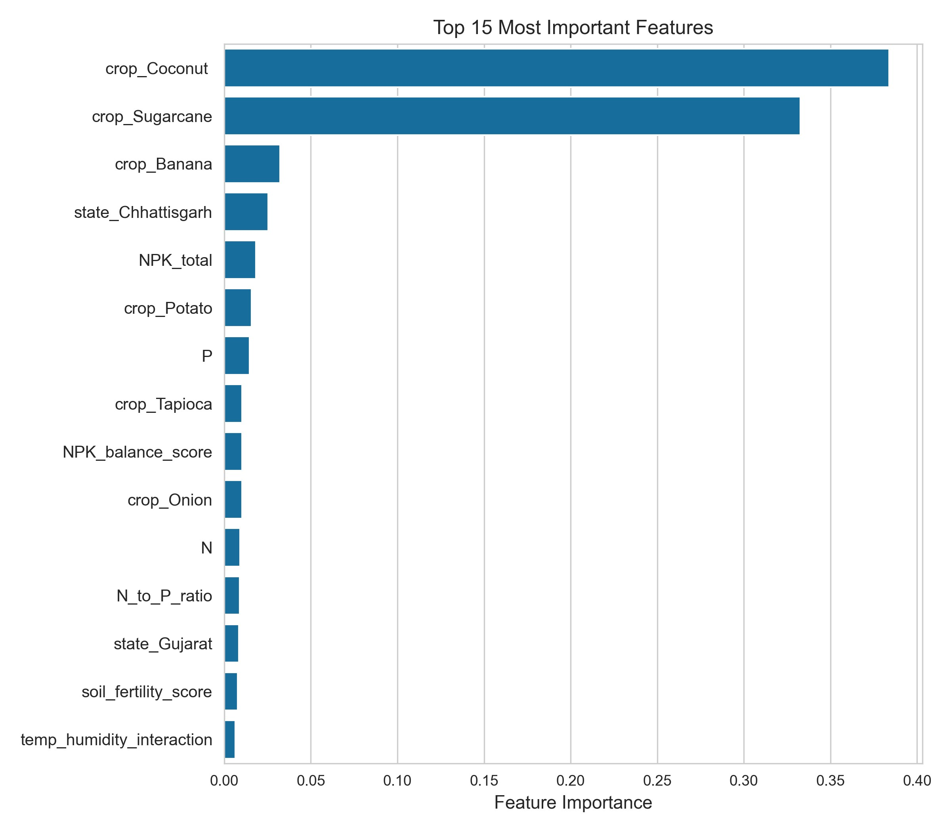
Fig. 5 Feature importance ranking derived from the Extra Trees model, highlighting the contribution of soil nutrient ratios, temporal features, and climate variables.

Discussion
The results demonstrate that non-linear ensemble models substantially outperform linear approaches for multi-crop yield prediction under temporal validation settings. The superior performance of the Extra Trees model (R² = 0.9506) highlights the importance of capturing complex interactions between soil nutrients, climate variables, and temporal dynamics.
The ablation study confirms that domain-driven feature engineering contributes significantly to predictive improvement. In particular, input efficiency features and nutrient balance ratios provided measurable gains, suggesting that agronomic knowledge enhances model interpretability and performance beyond raw input variables.
The limited incremental contribution of certain climate interaction features suggests that tree-based ensemble methods may implicitly capture non-linear dependencies without requiring extensive manual interaction construction. This finding aligns with previous research indicating the effectiveness of ensemble learning in heterogeneous agricultural environments Jeong et al. (2016); Khaki and Wang (2019); You et al. (2017).
The robustness observed across cross-validation folds and bootstrap analysis indicates that the proposed framework generalizes reliably and is not sensitive to sampling variability. The heterogeneity-aware evaluation across crop types, states, seasons, and time further supports the practical applicability of the model for decision-support systems in precision agriculture.
Overall, the study demonstrates that integrating multi-source agronomic data with structured feature engineering and rigorous temporal validation yields reproducible and scalable yield prediction performance.
Reported R² values in recent crop yield prediction studies typically range between 0.85 and 0.96 depending on crop type, spatial scale, and validation design Shawon et al. (2024). While certain national-scale models report higher values under partially structured validation schemes, performance under strict chronological separation is generally lower. The achieved R² = 0.9506 under temporal validation demonstrates competitive predictive capability while maintaining realistic forecasting integrity. The integration of agronomic knowledge with ensemble learning contributes to improved interpretability and practical relevance. By enforcing strict temporal validation and evaluating heterogeneity across multiple agricultural dimensions, the framework reduces the risk of performance overestimation commonly observed in random cross-validation schemes.

Conclusion
This study presented a multi-source machine learning framework for crop yield prediction integrating crop production statistics, soil nutrient parameters, and meteorological variables over a 24-year period. The incorporation of domain-driven feature engineering, including nutrient balance ratios and input efficiency indicators, significantly enhanced predictive performance.
Among evaluated models, the Extra Trees Regressor achieved the highest accuracy under chronological temporal validation, demonstrating strong capability in modeling complex soil-climate interactions. The structured ablation study and stability analysis confirmed that the proposed feature engineering strategy and validation design contribute to robust and reproducible performance.
The heterogeneity-aware evaluation across crop types, geographic regions, seasons, and years supports the applicability of the framework for precision agriculture decisionsupport systems. Future work may extend this approach by incorporating remote sensing data, finer spatial granularity, and real-time forecasting pipelines.

6 Declarations
Funding: The authors received no external funding for this research.
Conflict of Interest: The authors declare no conflict of interest.
Ethics Approval: Not applicable.
Consent to Participate: Not applicable.
Consent for Publication: All authors consent to publication.
Author Contributions: Conceptualization: Anshu Mishra; Methodology: Anshu
Mishra, Anshuman Mishra; Data Curation: Anu Kushwaha; Software: Anshu Mishra; Validation: Anushka Chand; Writing – Original Draft: Anshu Mishra; Writing – Review & Editing: All authors.
Data Availability: Crop data were obtained from publicly available Kaggle datasets (CC BY-SA 4.0). Soil data were compiled from the official ICAR portal. Weather data were retrieved from the NASA POWER Data Access Viewer. Processed datasets are available upon reasonable request.
Code Availability: Source code is available from the corresponding author upon reasonable request.

7 References
Abdel-Salam A, El-Hefnawy M (2024) Hybrid feature selection and ensemble learning for crop yield estimation. Computers and Electronics in Agriculture 214:108321
Ashfaq M, Ali H, Khan A (2025) Multi-source machine learning framework for national-scale crop yield prediction. Computers and Electronics in Agriculture 219:108181
Cao J, Zhang Z, Tao F (2021) Integrating multi-source data for regional crop yield prediction. Agricultural and Forest Meteorology 307:108474
Gupta A (2023) Crop yield in indian states dataset. Kaggle Dataset, available under CC BY-SA 4.0
Indian Council of Agricultural Research (2023) Icar soil nutrient statistics portal. Official ICAR Portal
Jeong JH, Resop JP, Mueller ND, et al (2016) Random forests for global and regional crop yield predictions. PLoS ONE 11(6):e0156571
Khaki S, Wang L (2019) Crop yield prediction using deep neural networks. Frontiers in Plant Science 10:621
Killeen D, Perez L, Johnson R (2024) Impact of spatial cross-validation on crop yield prediction accuracy. Agricultural Systems 215:103487
Muruganantham P, Weng Q, Huang Y (2022) Crop yield prediction using machine learning and remote sensing: A review. Agricultural Systems 196:103324
NASA Langley Research Center (2023) Nasa power data access viewer. https://power.larc.nasa.gov/data-access-viewer/
Paudel D, Boogaard H, de Wit A (2020) Incorporating agronomic knowledge in crop yield prediction models. Field Crops Research 249:107756
Shawon M, Rahman M, Islam S (2024) Recent advances in machine learning for crop yield prediction: A systematic review. Precision Agriculture 25:1–24
Van Klompenburg T, Kassahun A, Catal C (2020) Crop yield prediction using machine learning: A systematic literature review. Computers and Electronics in Agriculture 177:105709
You J, Li X, Low M, et al (2017) Deep gaussian process for crop yield prediction based on remote sensing data. Proceedings of the AAAI Conference on Artificial Intelligence 31(1)

